**Table of Contents**

### **1. Docker Execution**

1.1 Docker Containers (Docker Desktop)  
 1.2 docker ps Output  
 1.3 Docker Logs

### **2. Service Dashboard**

2.1 Eureka Server Dashboard

### **3. Config Server Console**

3.1 Config Server Console – Booking-Service  
 3.2 Config Server Console – Flight-Service  
 3.3 Config Server Console – API Gateway  
 3.4 Config Server Console – Notification-Service  
 3.5 Flight-Configs (Git Repository)

### **4. Notification Service (RabbitMQ + Email)**

4.1 RabbitMQ Dashboard  
 4.2 Booking Confirmation Email  
 4.3 Notification-Service Success Log

### **5. Spring Security**

5.1 Admin Authentication  
 5.2 User Authentication

### **6. Swagger API Documentation**

### **7. Performance Evaluation using JMeter**

### **8. JaCoCo Test Coverage Report**

### **9. Code Coverage using SonarCloud**

**Docker Execution**

1. **Docker Containers (Docker desktop)**

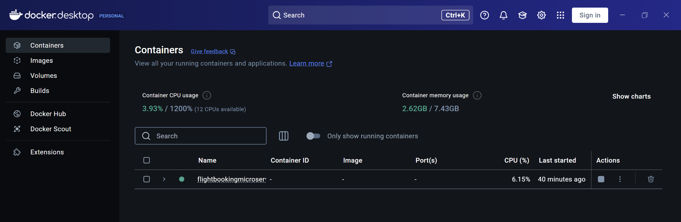

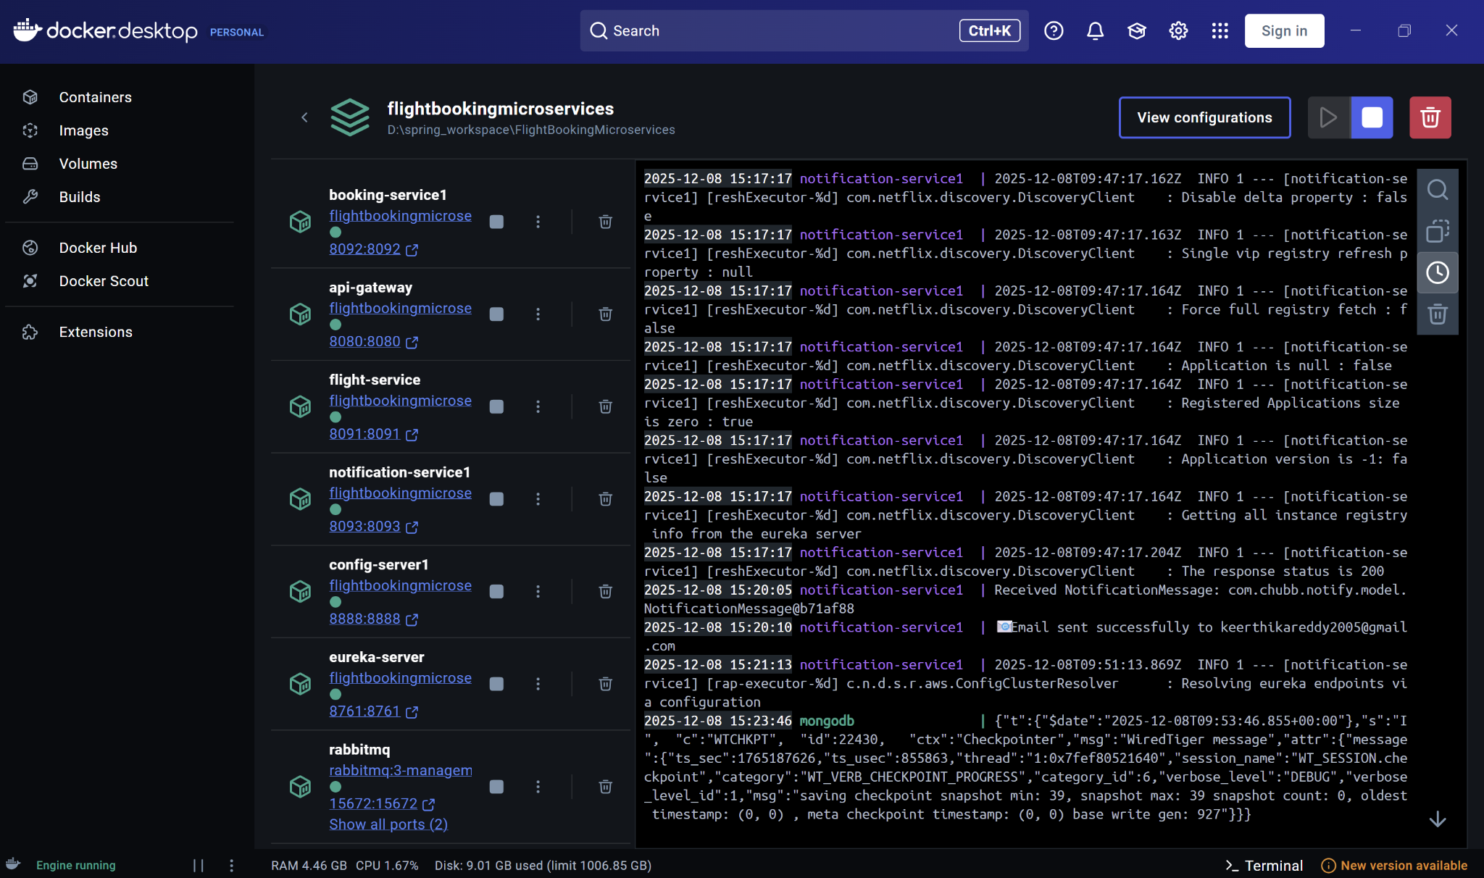

1. **Docker ps**

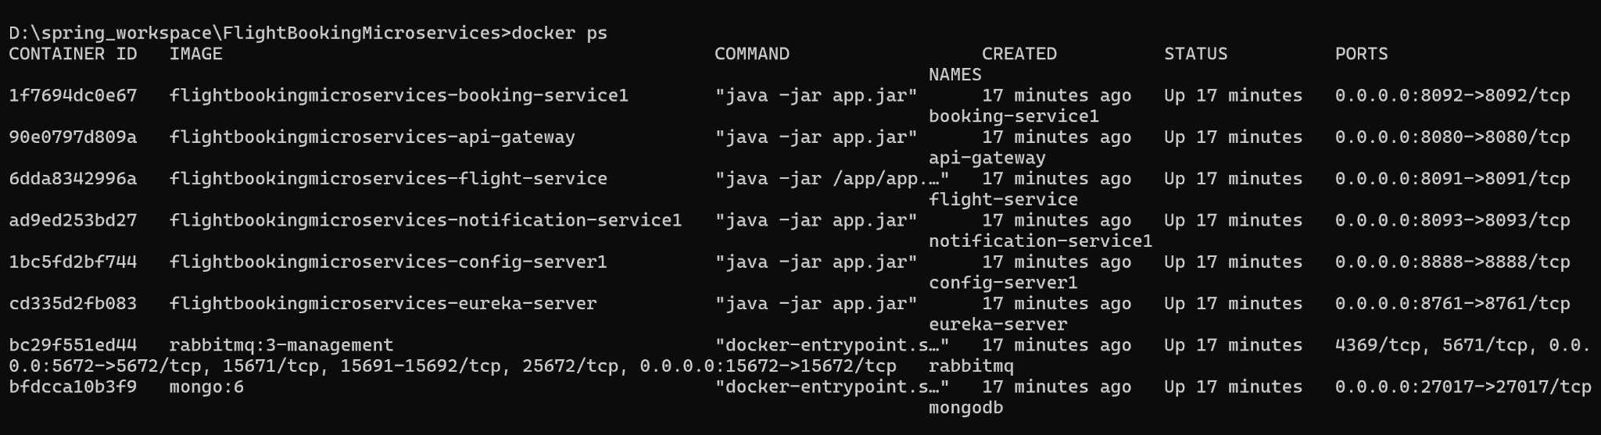

1. **Docker logs**

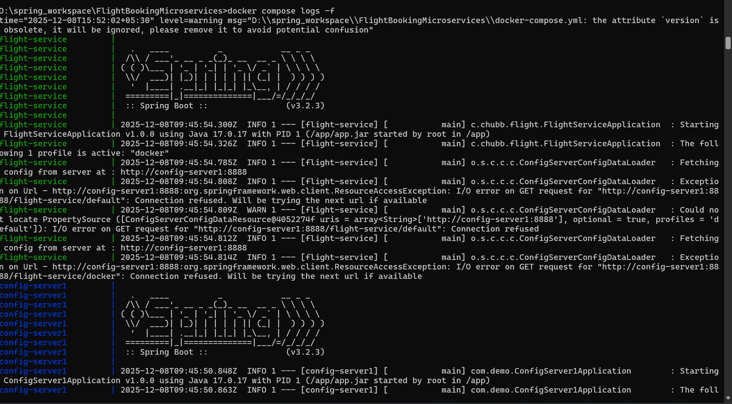

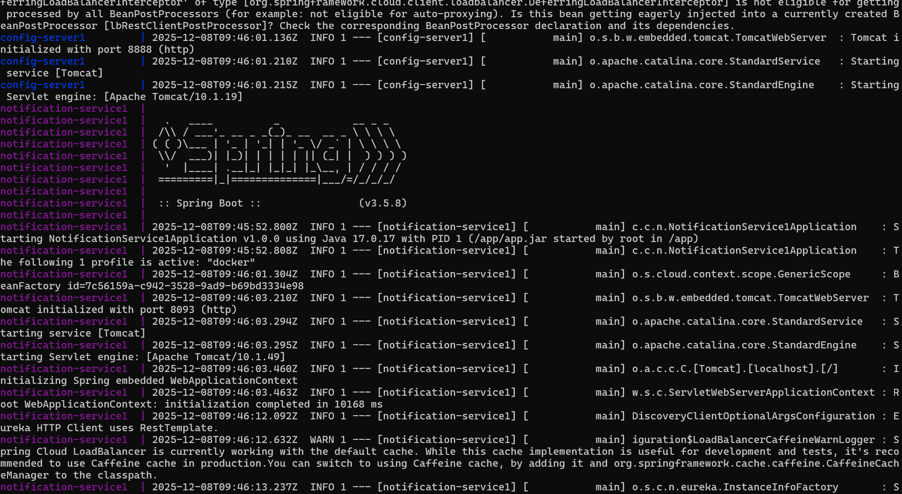

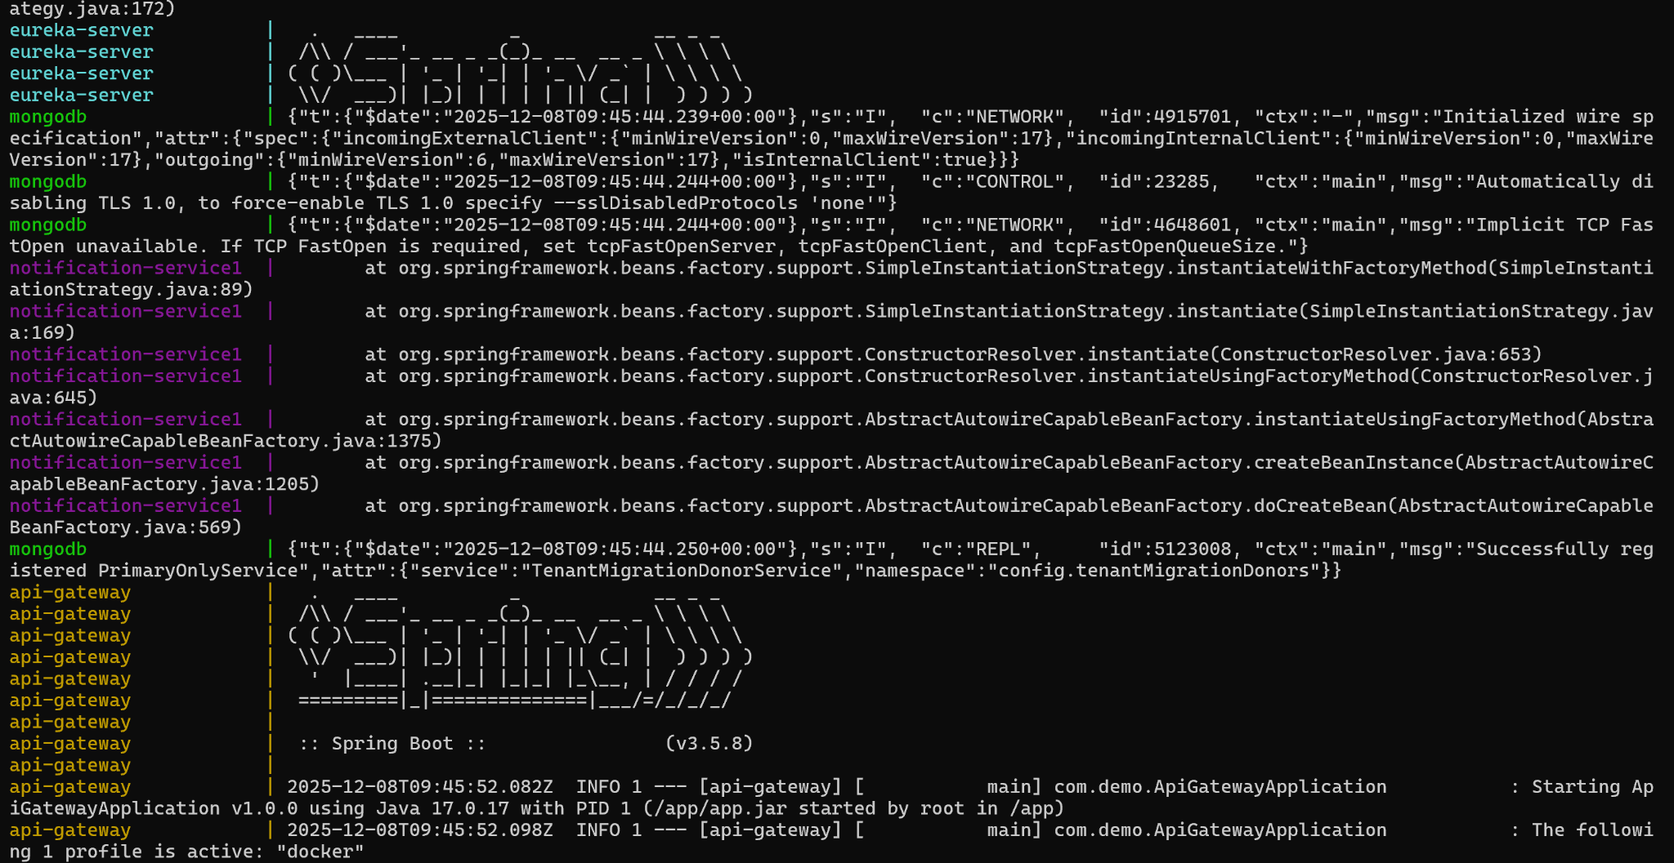

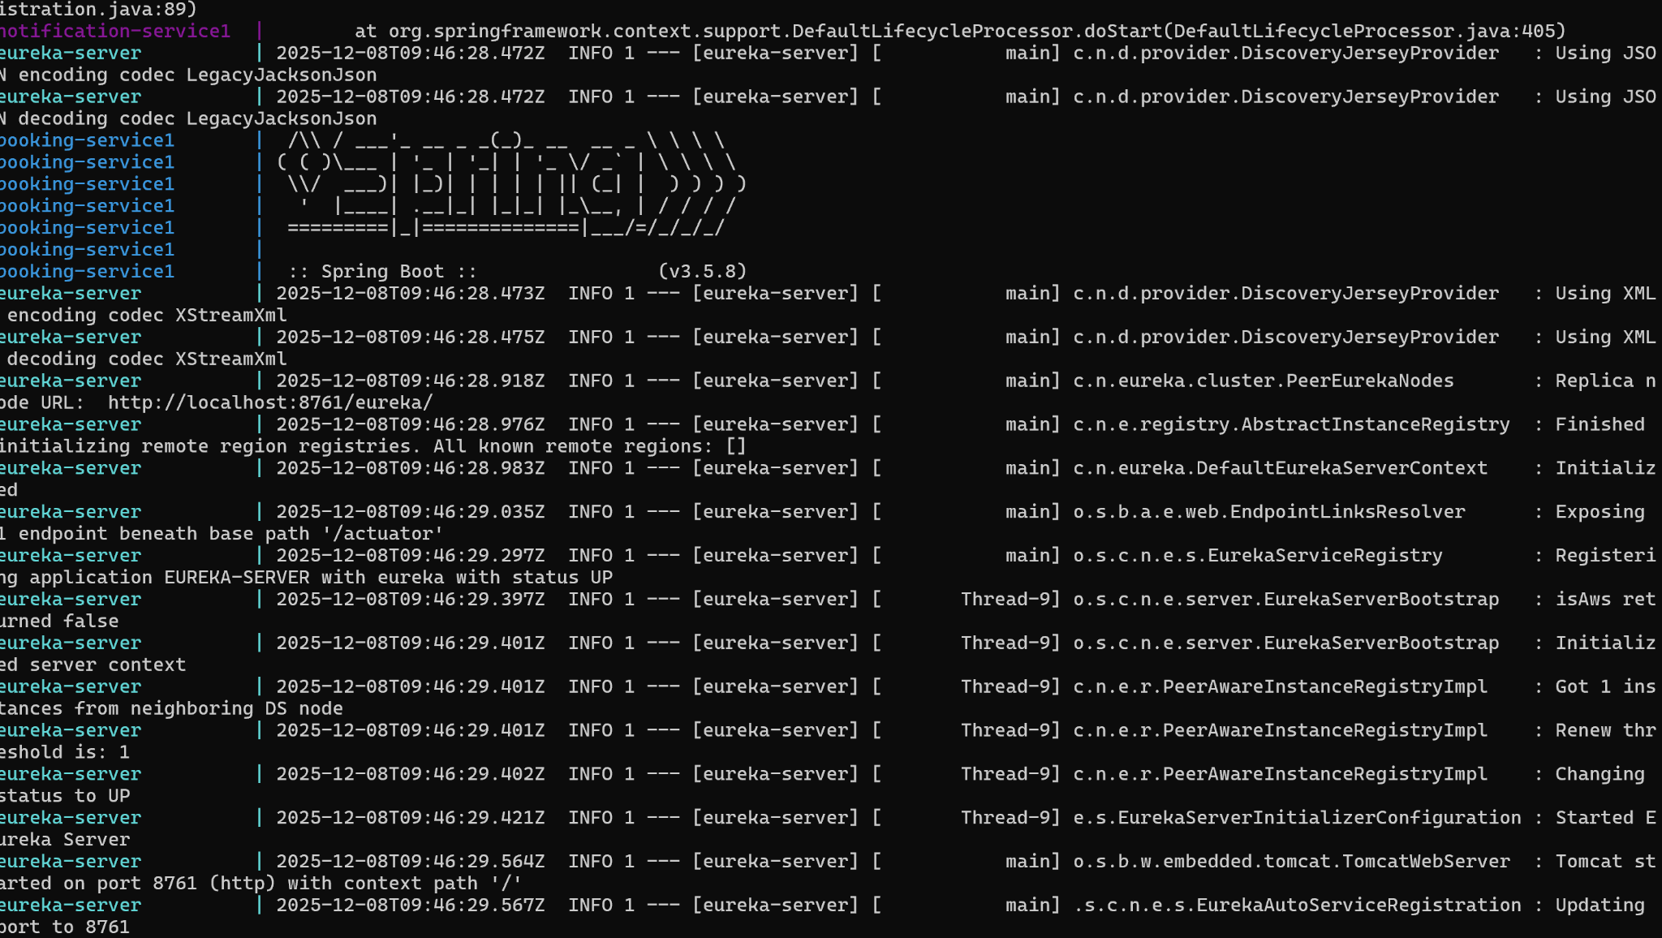

**Service Dashboard**

1. **Eureka Server Dashboard**

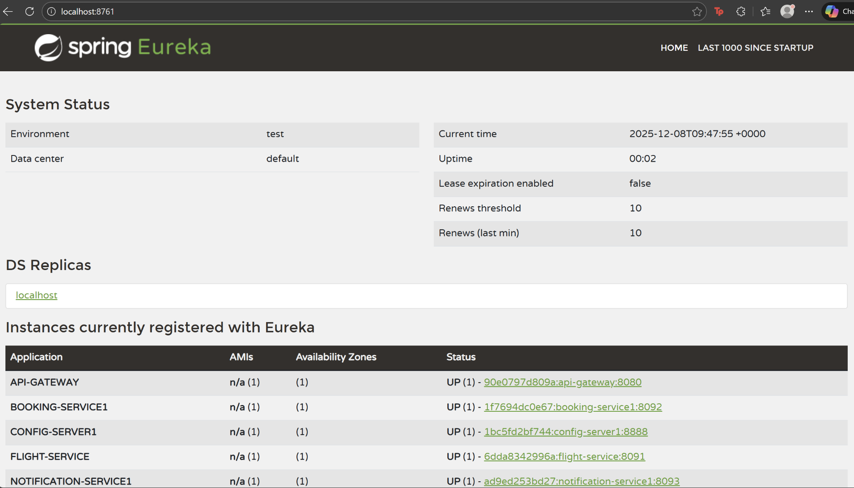

1. **Config Server Console (booking-service)**

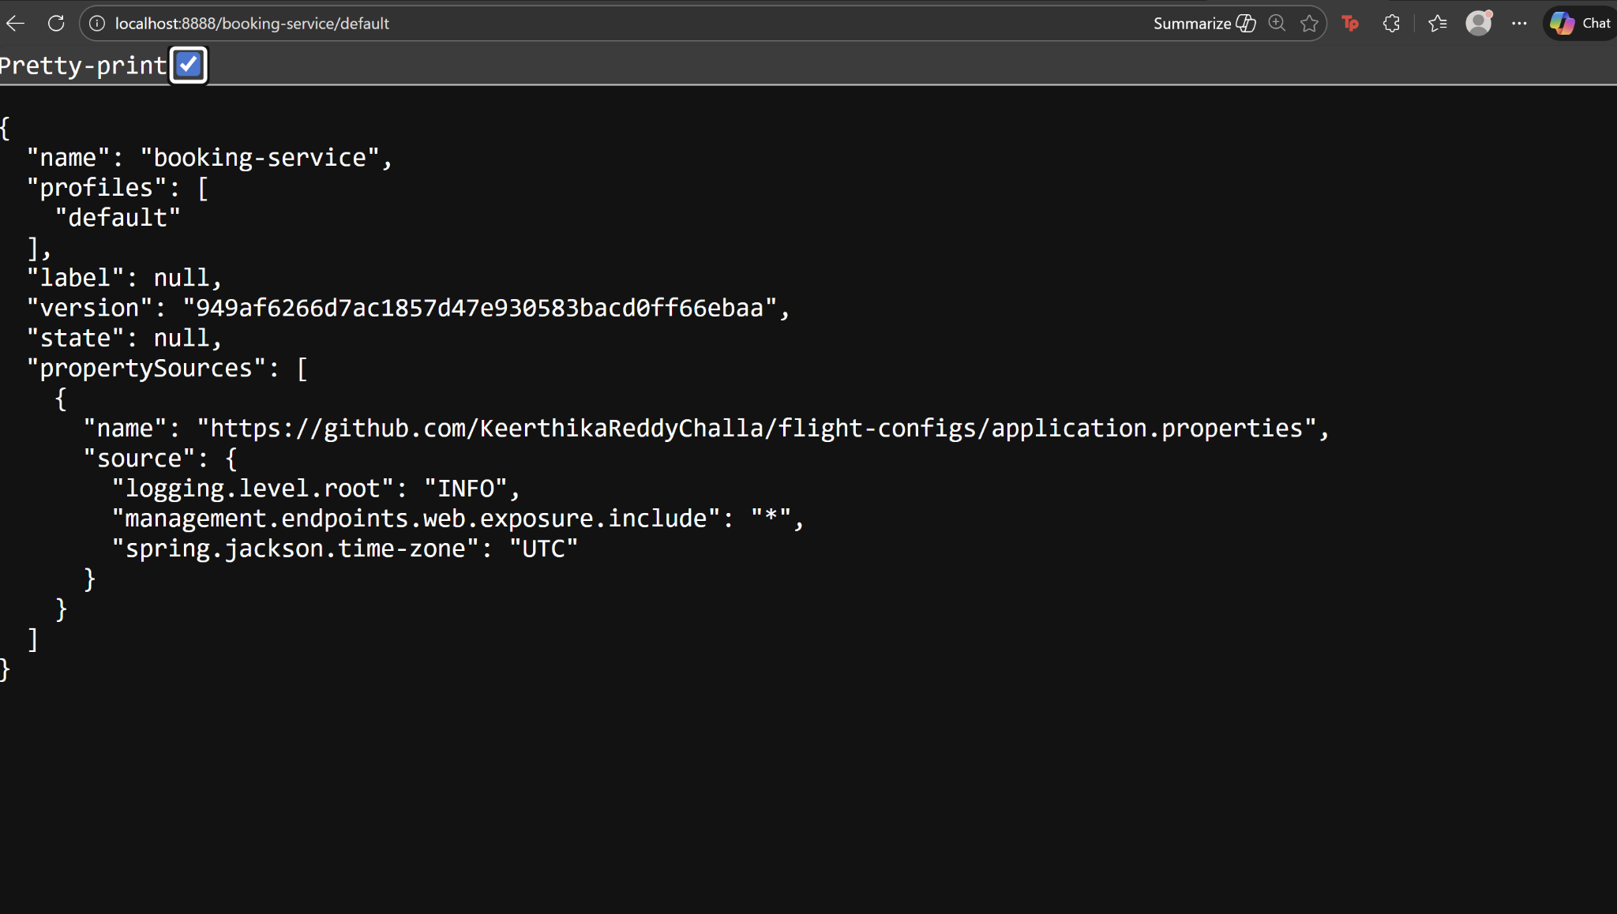

1. **Config Server Console (flight-service)**

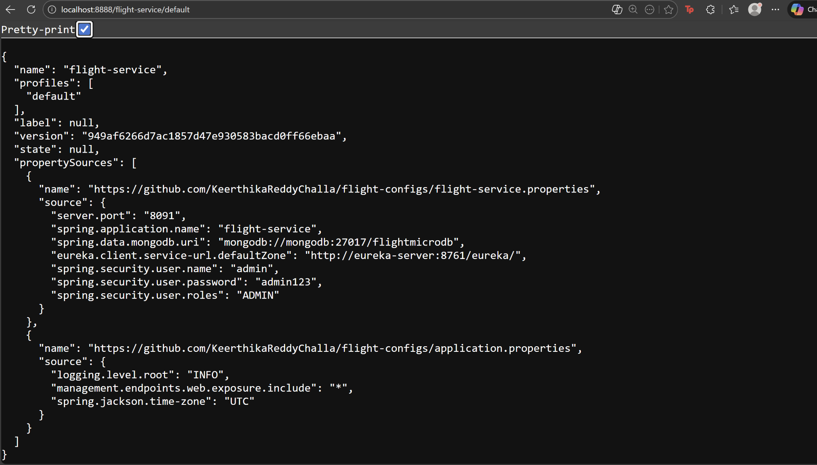

1. **Config Server Console (api-gateway)**

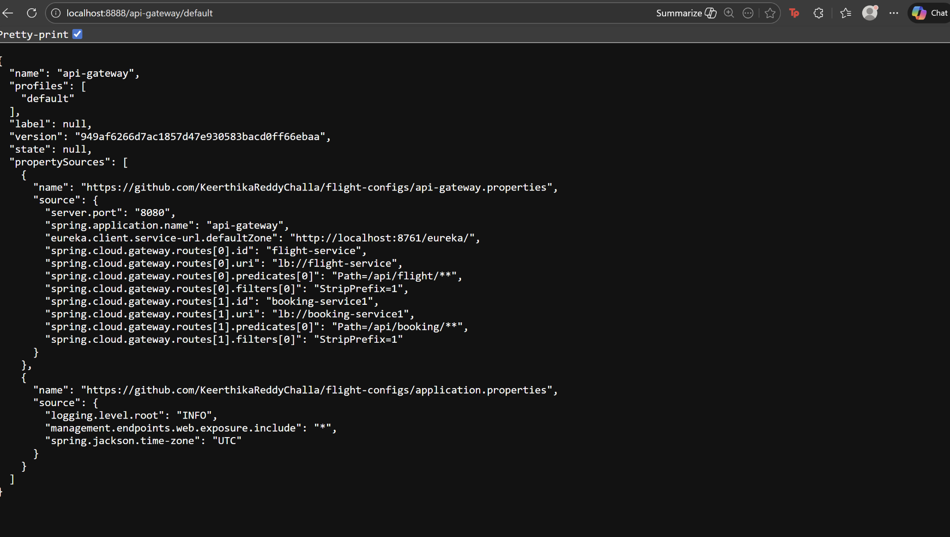

1. **Config Server Console (notification-service)**

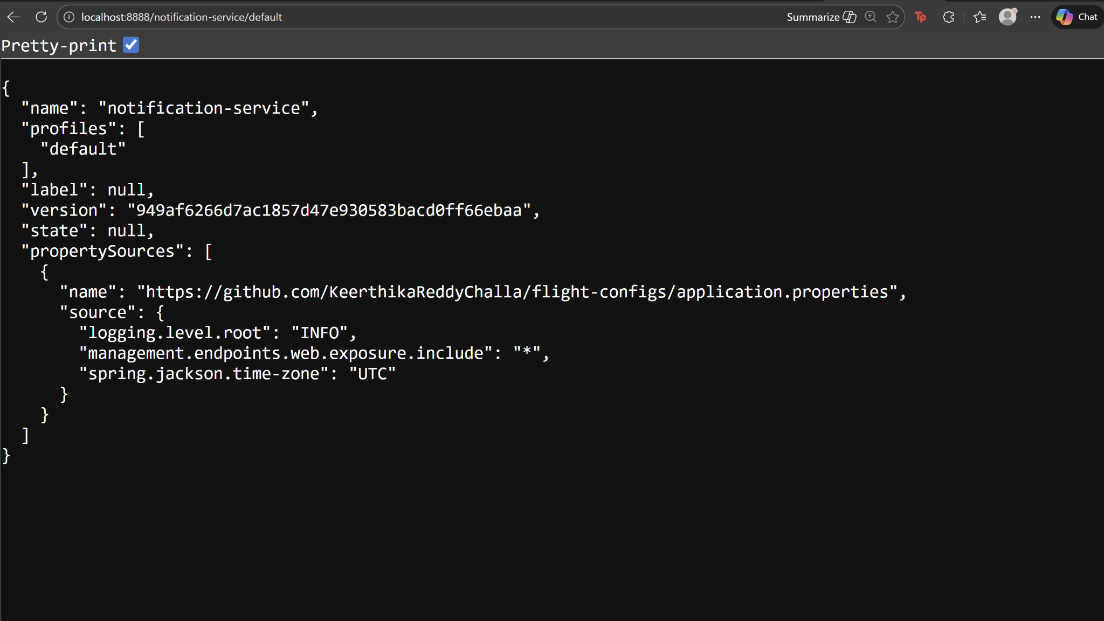

1. **flight-configs (git repository)**

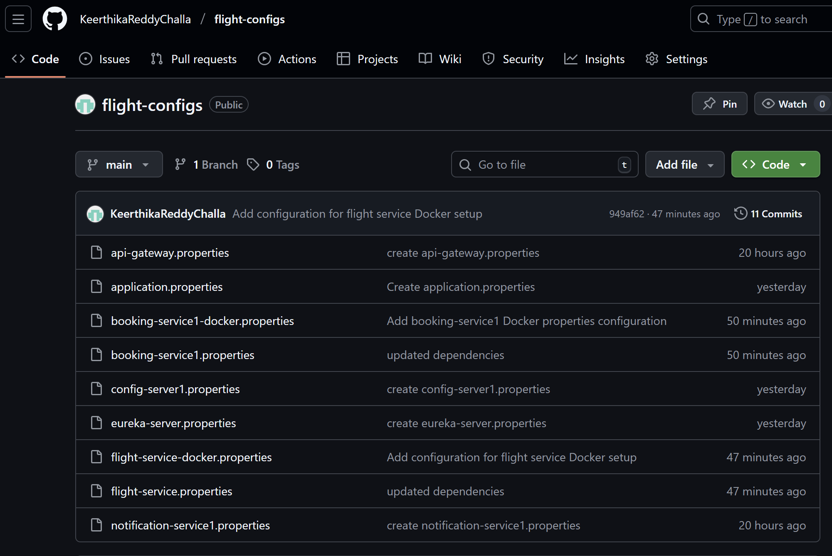

**Notification-Service (RabbitMQ + Email)**

1. **RabbitMQ Dashboard**

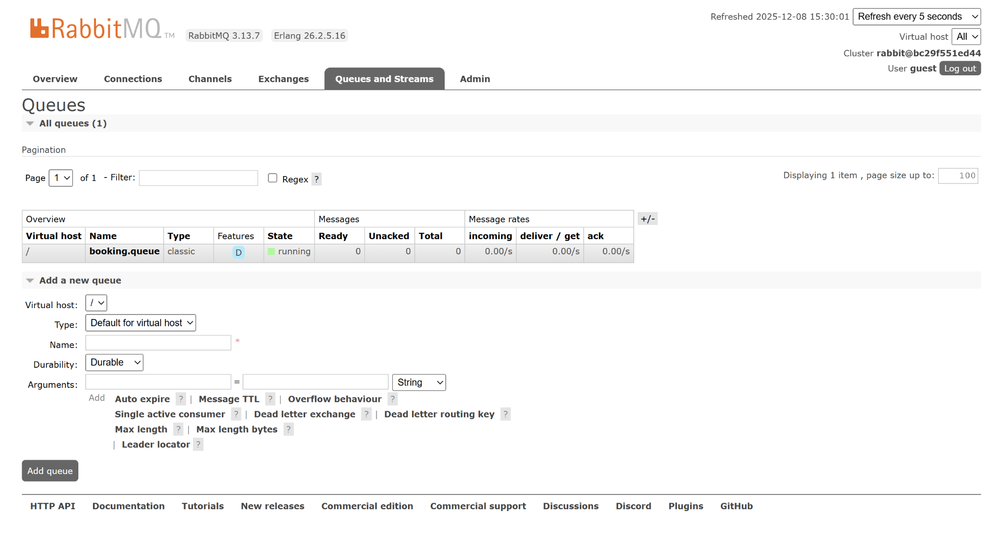

1. **Booking confirmation email**

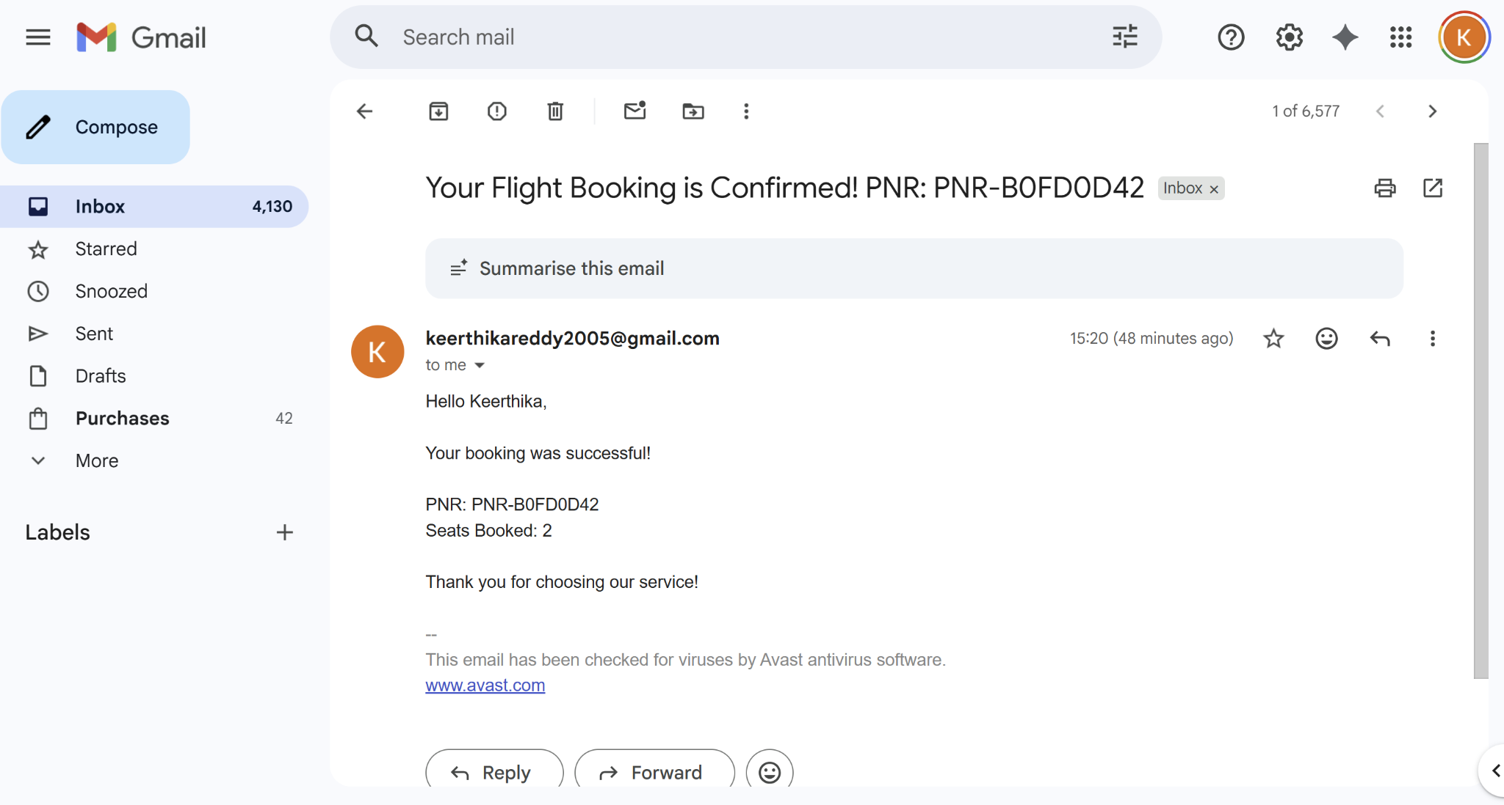

1. **Notification-service success log**

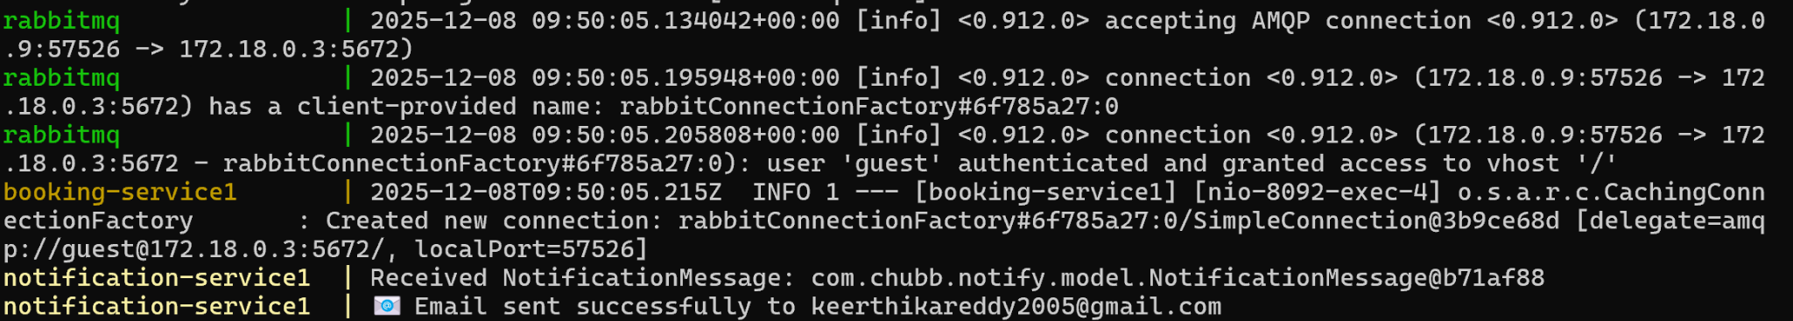

**Spring Security**

1. **Admin authentication**

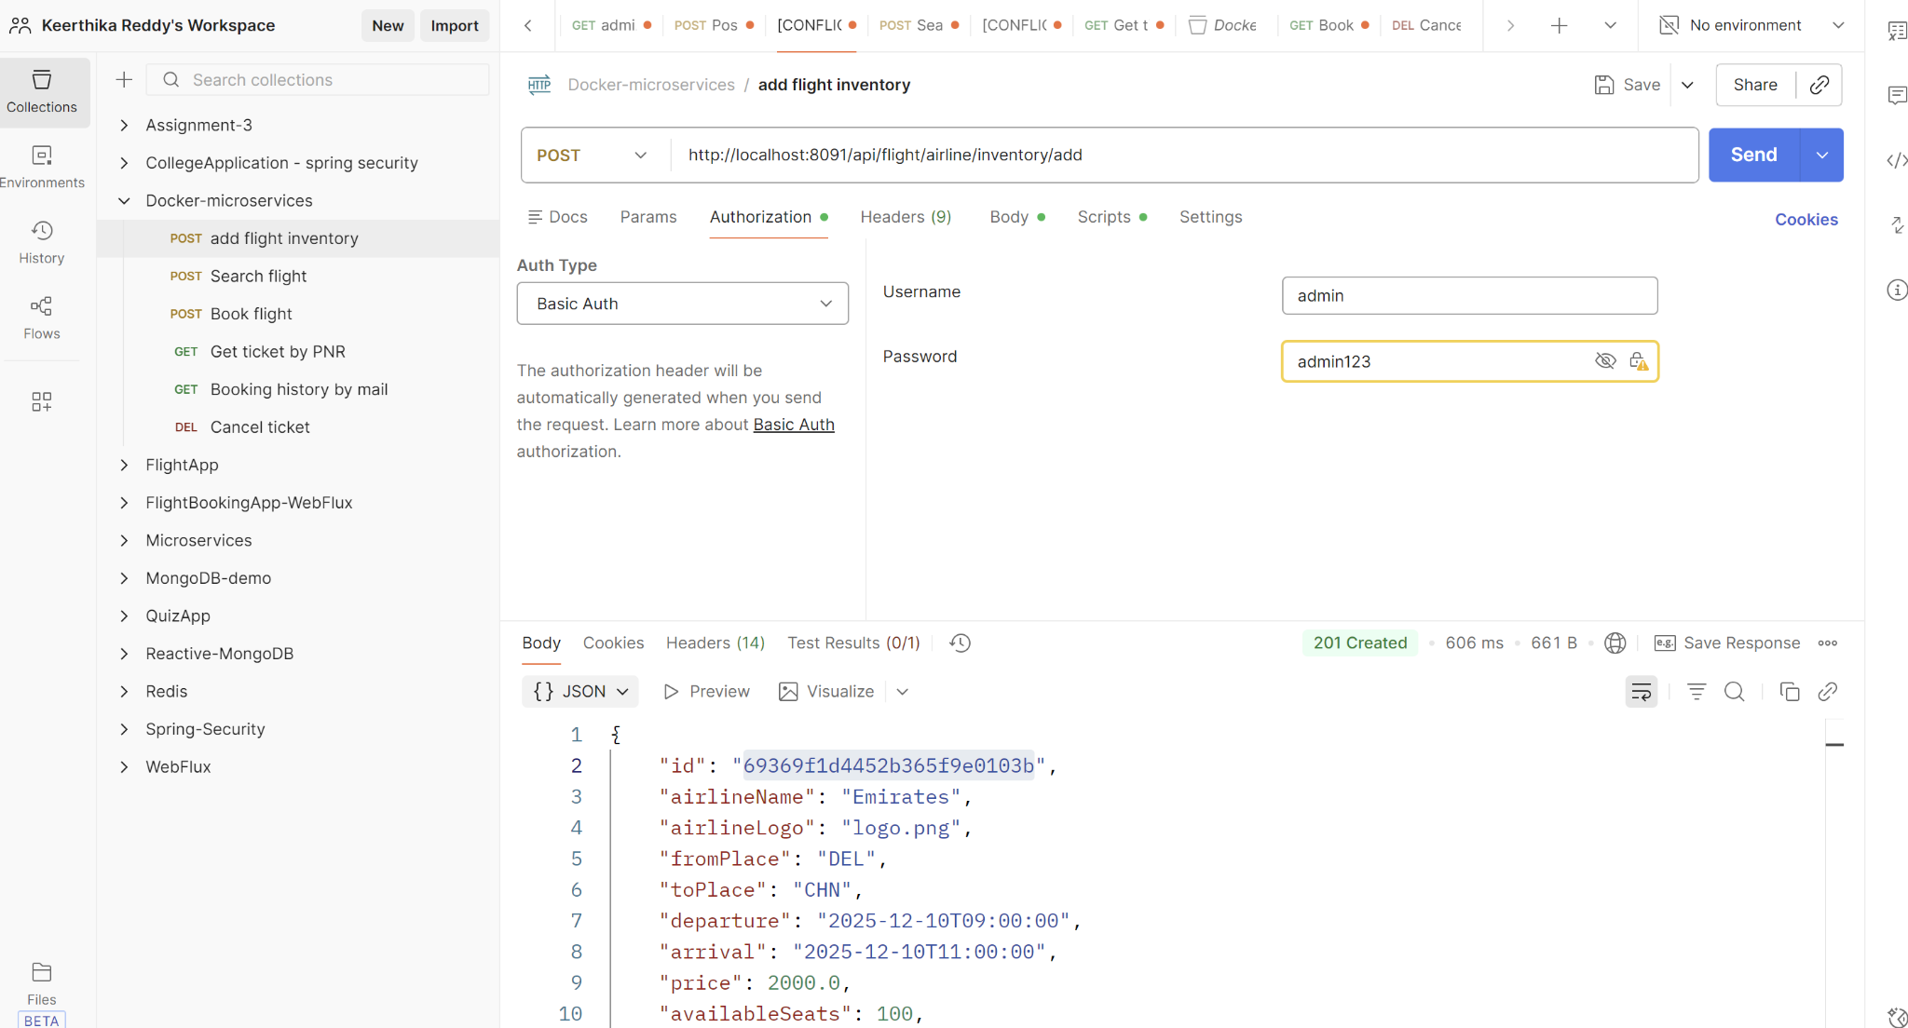

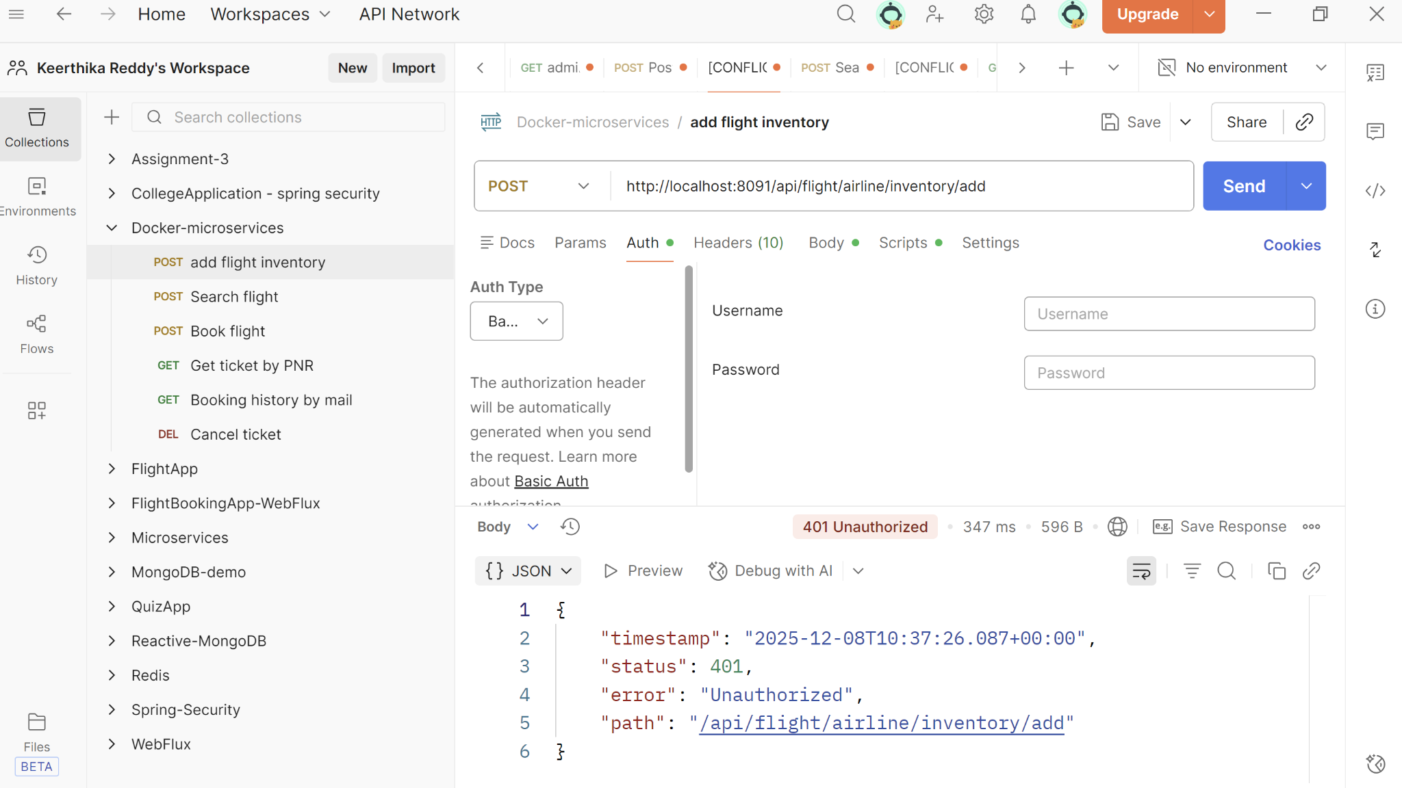

1. **User authentication**

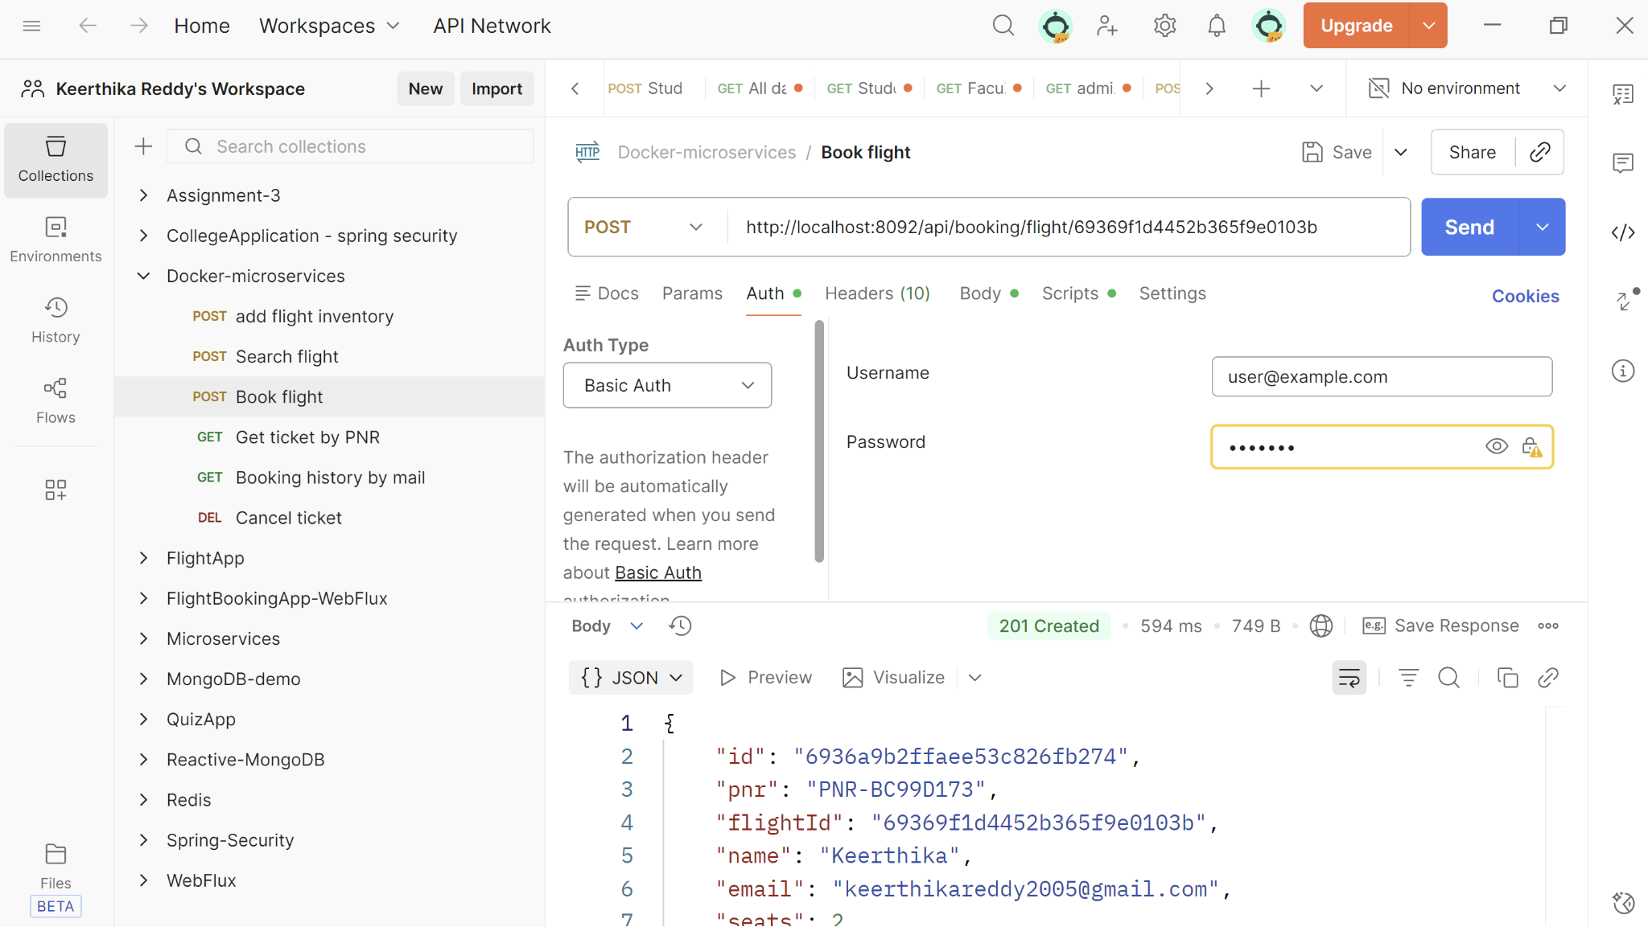

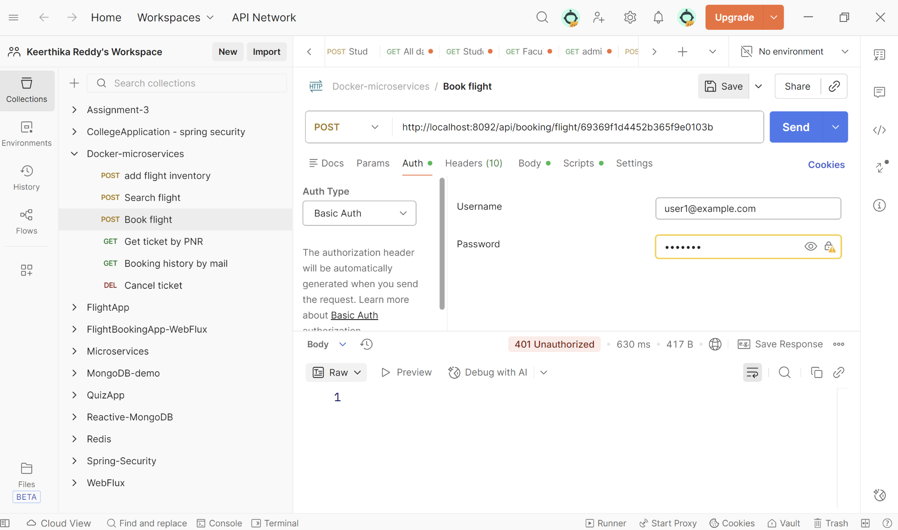

**Swagger API Documentation**

1. **Flight-service API documentation**

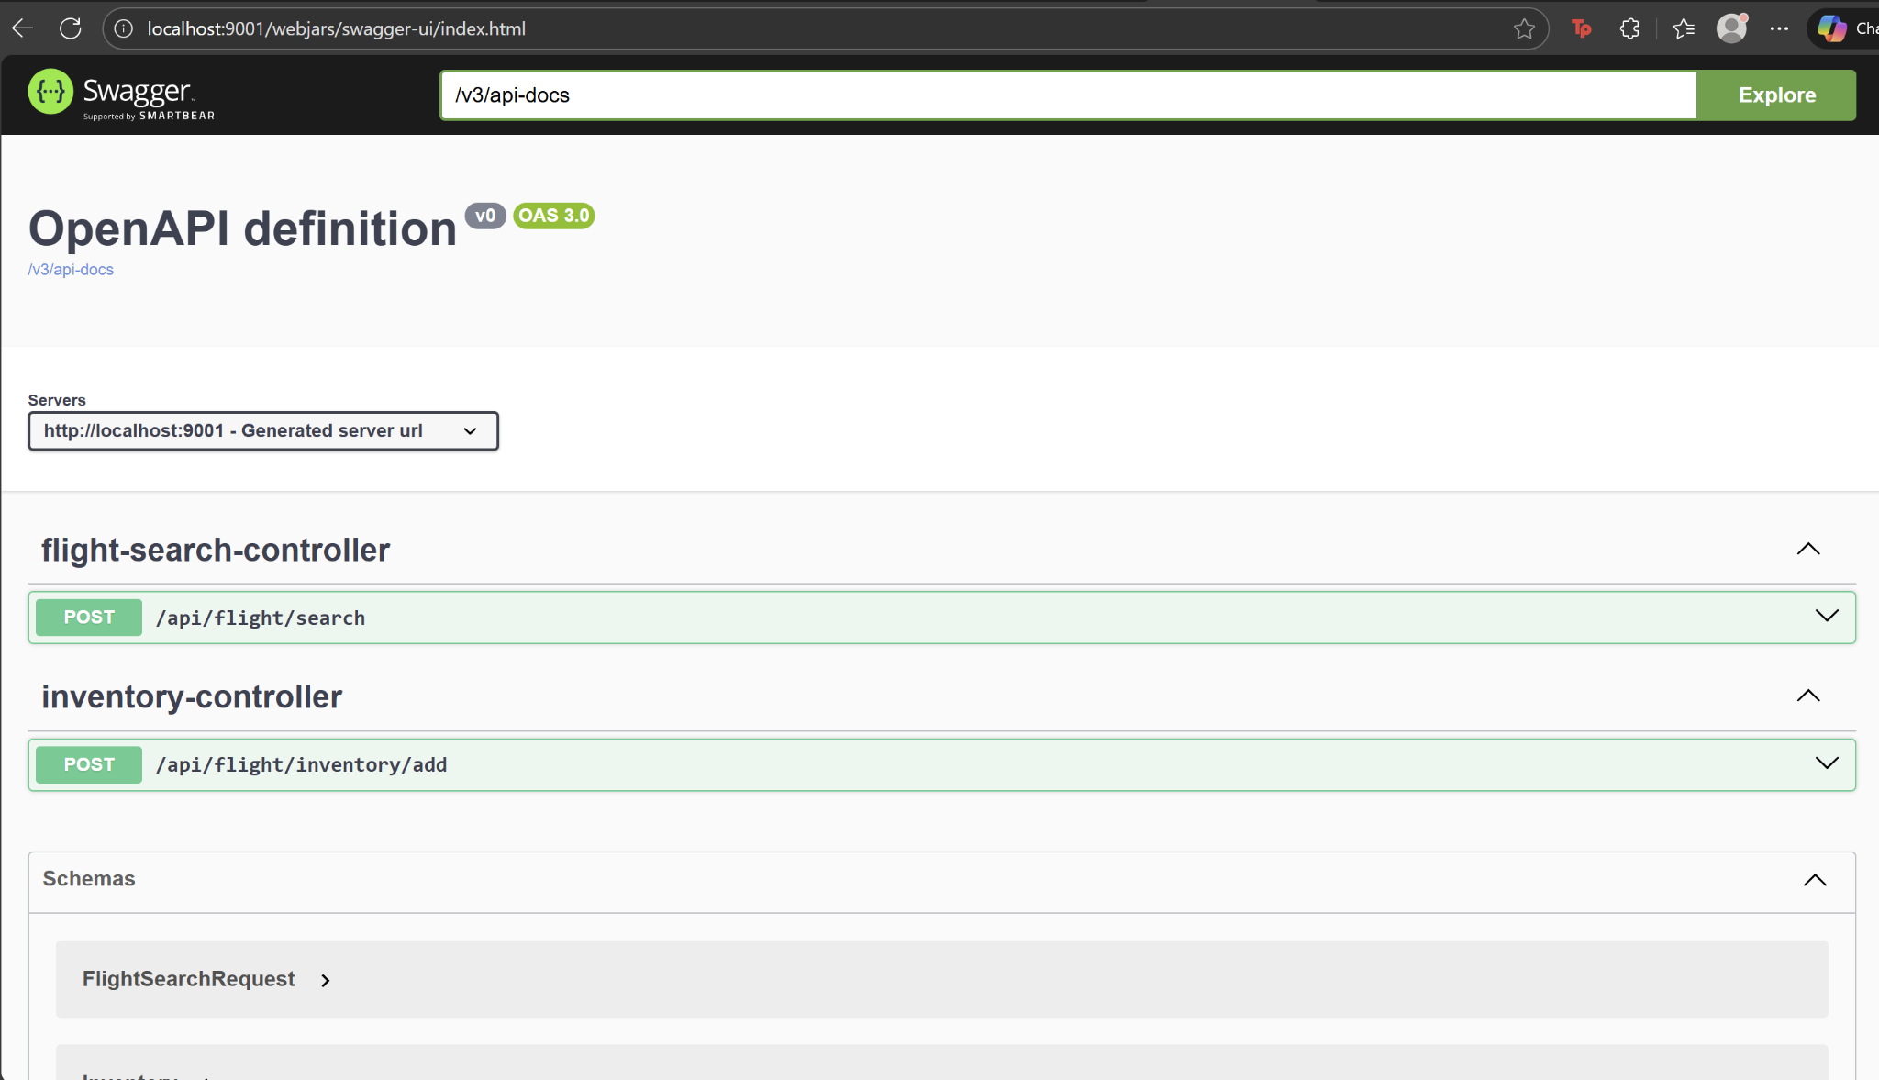

1. **Booking-service API documentation**

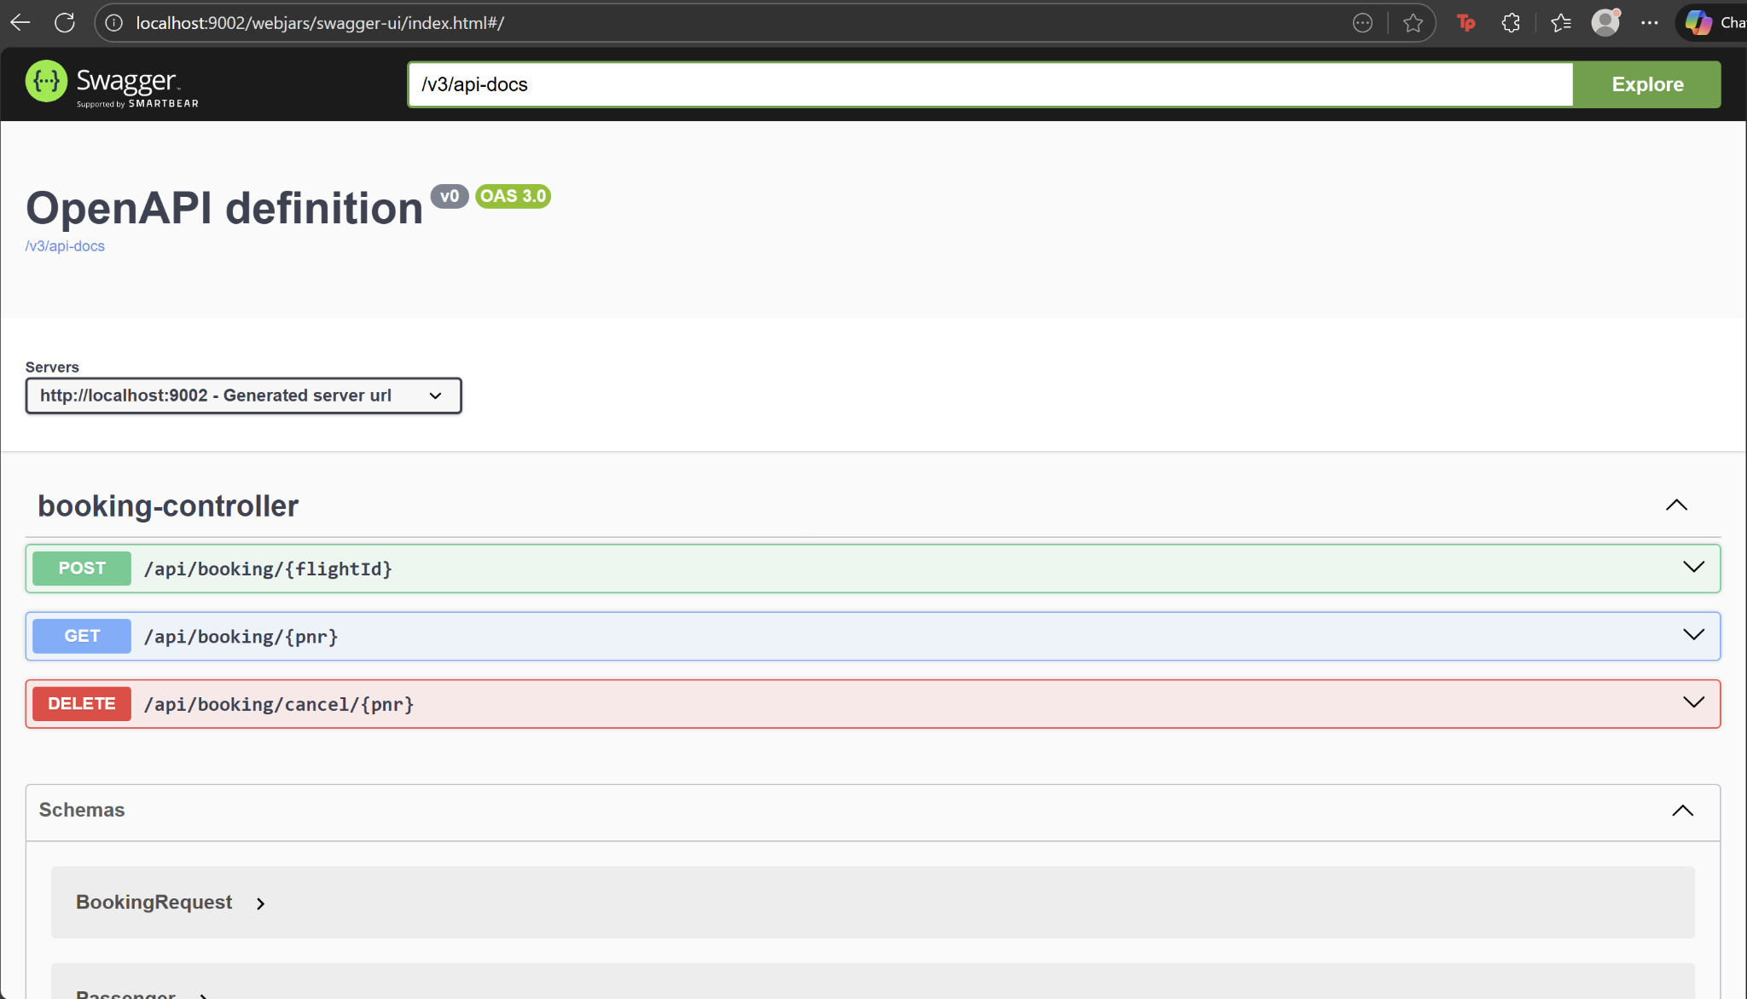

**Performance Evaluation using JMeter**

1. **Jmeter Results tree**

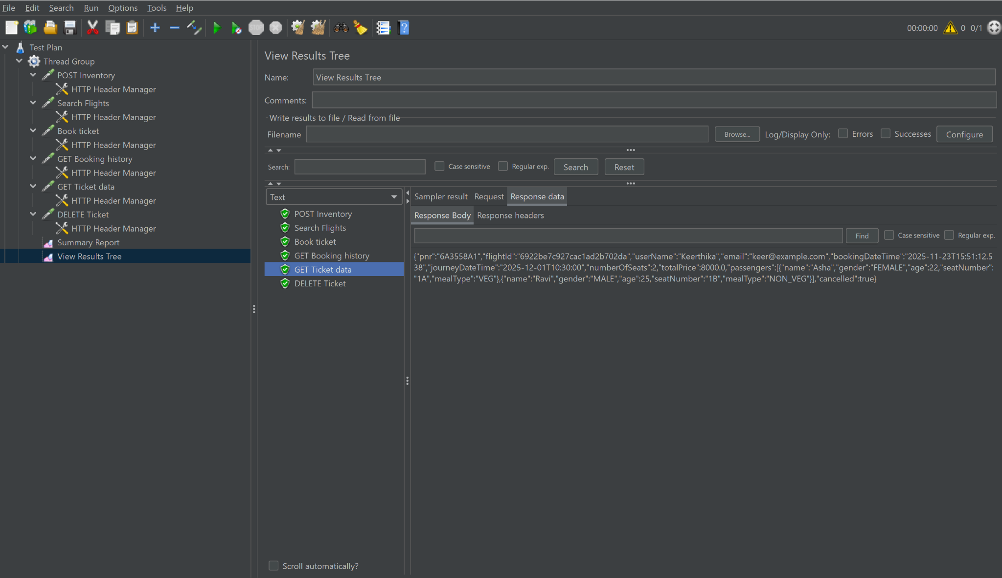

1. **Jmeter Summary-report (1-sample)**

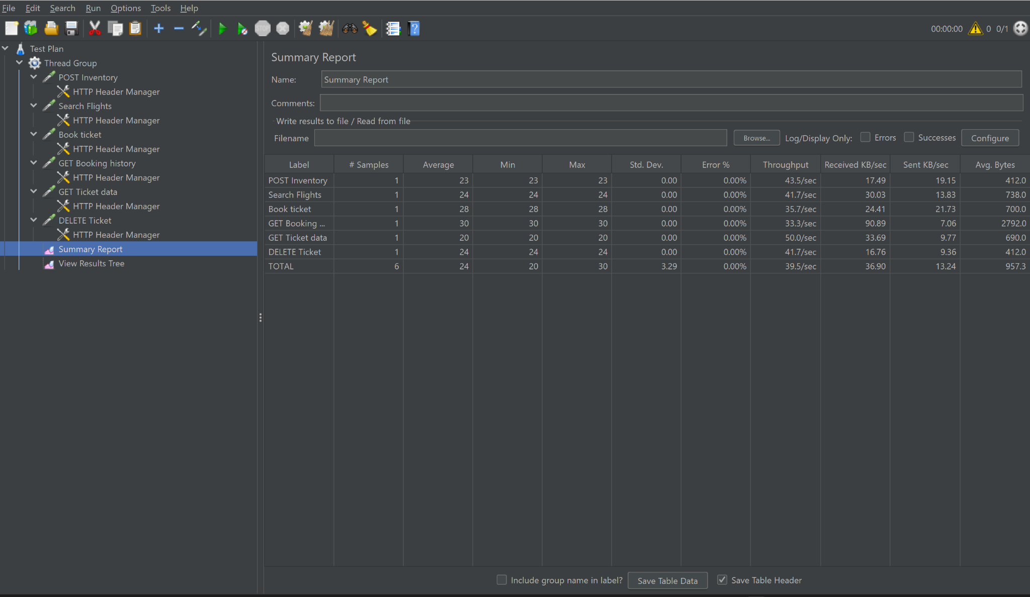

1. **Jmeter Summary-report (20-samples)**

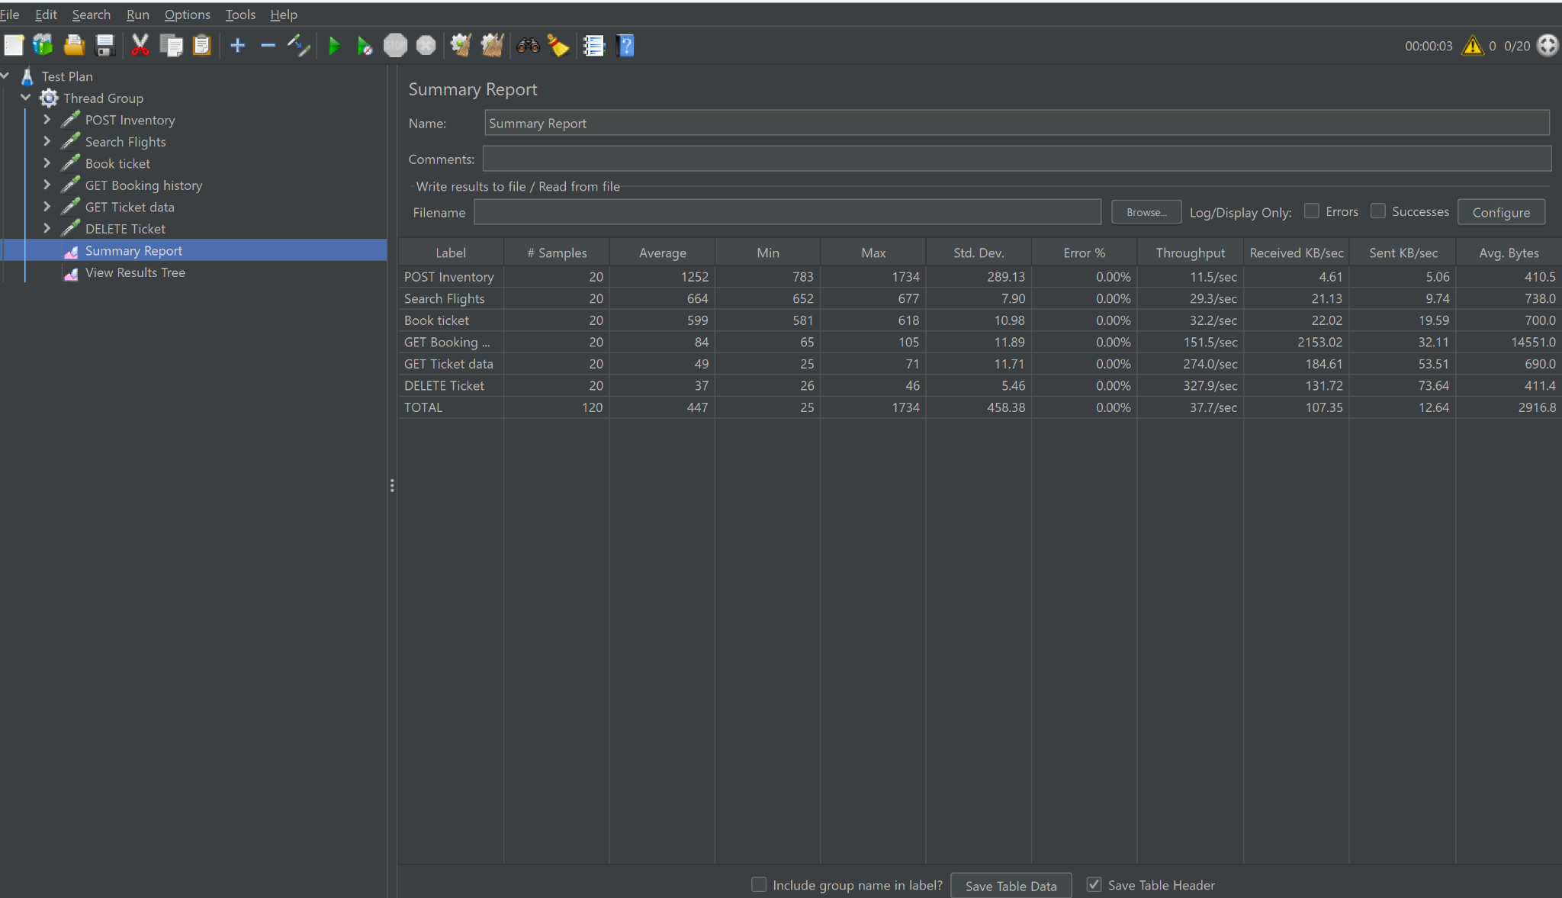

**Jacoco Test coverage report**

1. **Flight-Service JaCoCo Report**

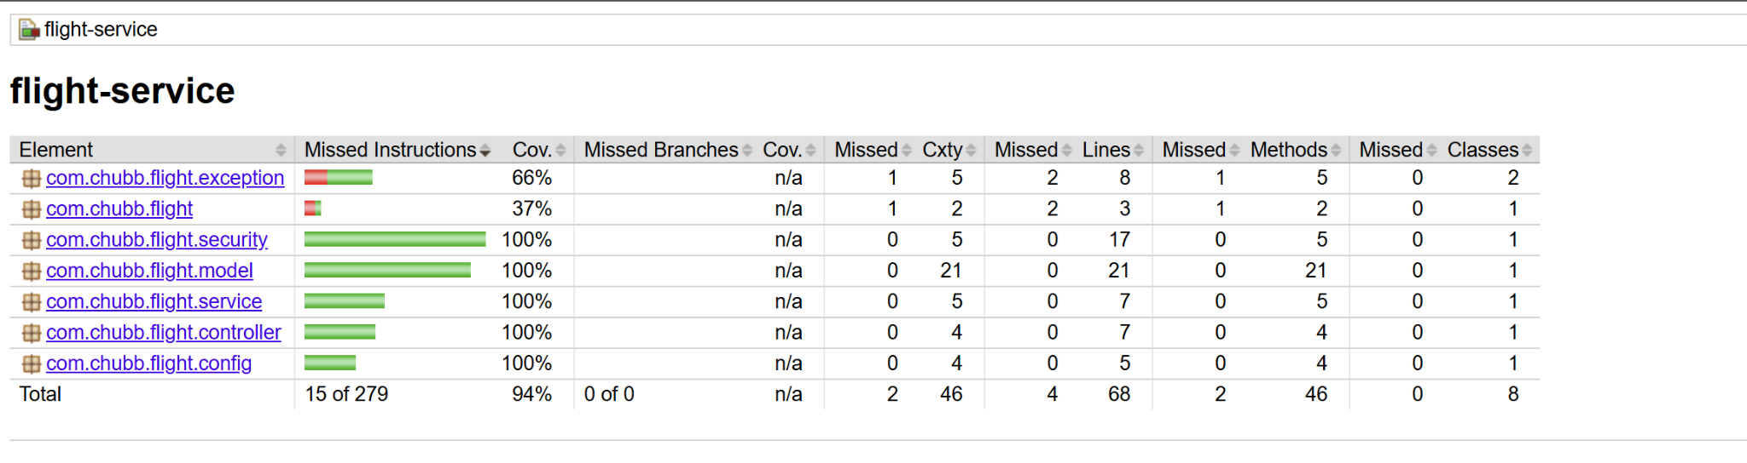

1. **Booking-Service JaCoCo Report**

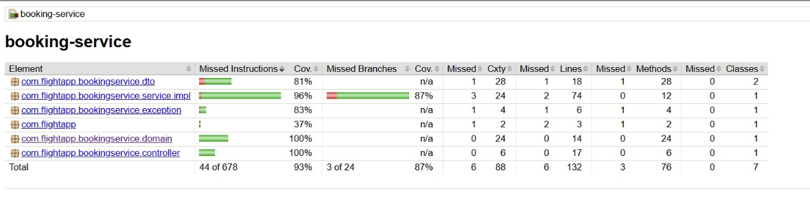

**Code Coverage using SonarCloud**

